Seminar seven

Wangweicheng 2176112412

1. **Topic :**
   1. *The aim of topic* **:**
      1. For hard-switching Buck converter:
2. Observe the switching waveform of power switch Q
3. Plot loss curve



Figure.1 Hard-Switching Buck Converter

* + 1. For ZVS QRC Buck converter:

1. Observe the switching waveform of power switch Q
2. Plot loss curve and compare with previous case



Figure.2 ZVS QRC Buck Converter

1. **Simulation models and settings:**
   1. *hard-switching buck converter:*

We built simulation circuit shown below:

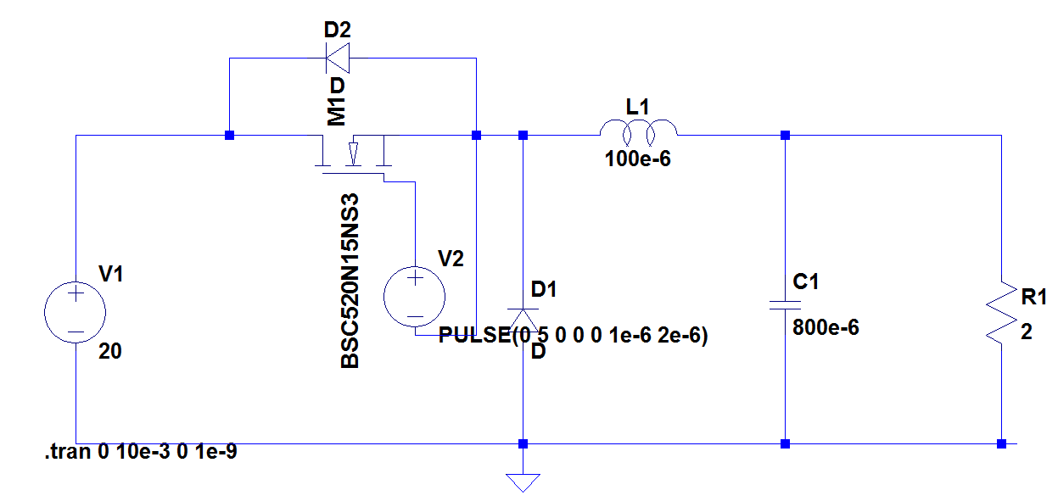Figure3: simulation circuit of hard-switching buck converter.

The following table shows all the parameters we used in this simulation:

Table 1: parameters in the simulation of hard-switching buck converter

|  |  |  |
| --- | --- | --- |
| parameter | value | unit |
| V1 | 20 | V |
| L | 100 | μH |
| C | 800 | μF |
| R | 2 | Ω |
| D | 0.5 |  |
| fs | 500 | kHZ |
| MOSFET | BSC060N10NS3 |  |

* 1. *ZVS QRC Buck converter:*

We built simulation circuit shown below:

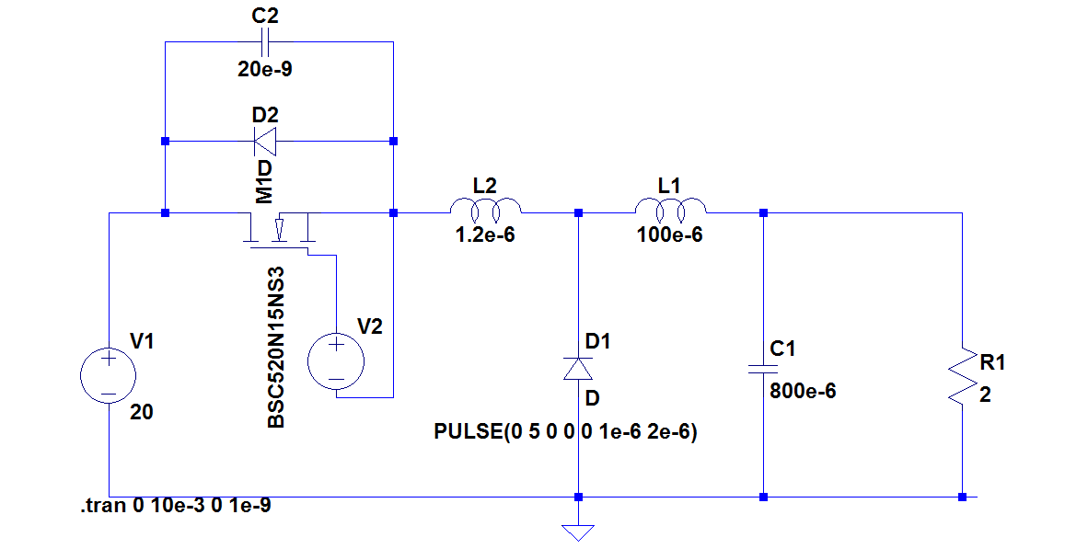

Figure 4: simulation circuit of ZVS QRC Buck converter

The following table shows all the parameters we used in this simulation:

Table 2: parameters in the simulation of ZVS QRC Buck converter

|  |  |  |
| --- | --- | --- |
| parameter | value | unit |
| V1 | 20 | V |
| L | 100 | μH |
| C | 800 | μF |
| Lr | 1.2 | μH |
| Cr | 20 | nF |
| R | 2 | Ω |
| D | 0.5 |  |
| fs | 500 | kHZ |
| MOSFET | BSC060N10NS3 |  |

And since all the switching processes happen in nanoseconds, the maximum time step should be even smaller. In this simulation, we set the maximum time step as $5×{10}^{-10}s$.

1. **results and discussion:**
   1. *hard-switching buck converter:*

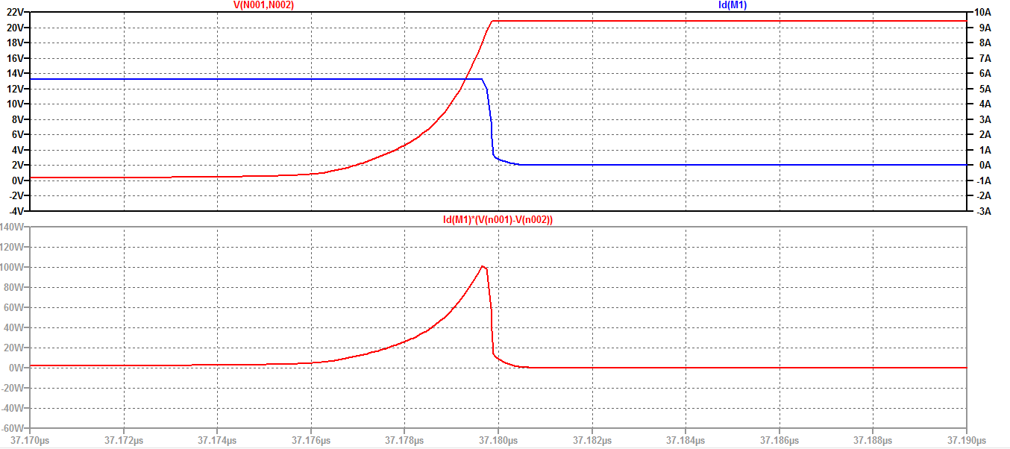The switching waveform of the hard-switching buck converter is shown in the following figure. Since the switching process is really short time relative to the switching period, we divide it into two figure: the open waveform and the close waveform:

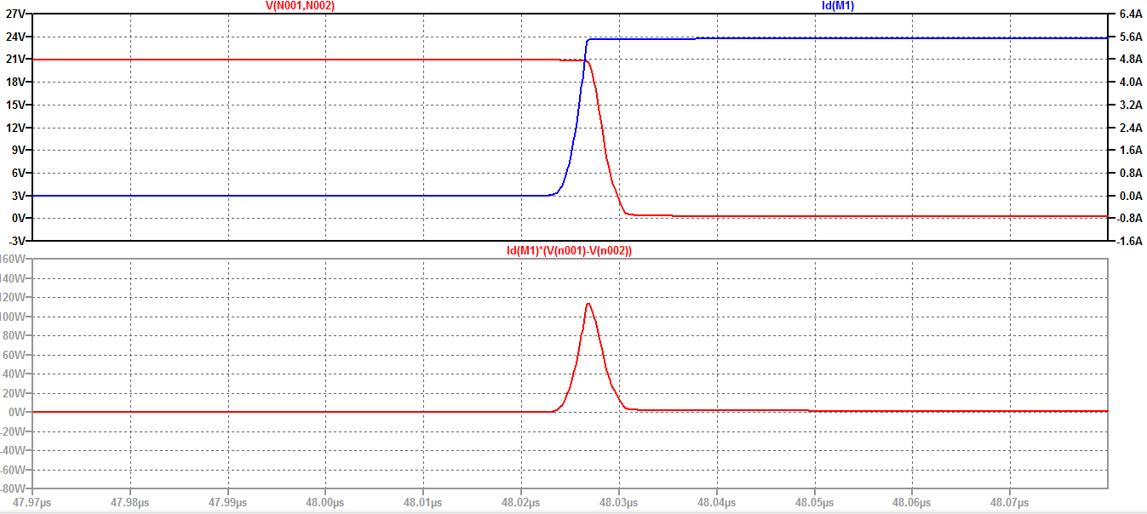Figure 5: closing waveform and loss curve of the hard-switching buck convertor

Figure 6: opening waveform and loss curve of the hard-switching buck convertor

* 1. *ZVS QRC Buck converter:*

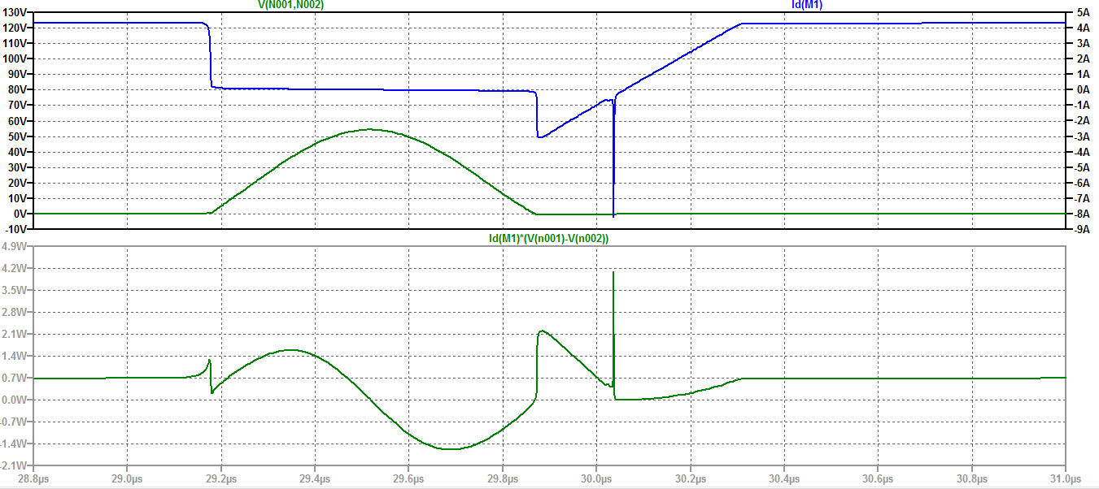The switching waveform is shown in the following figure:

Figure 7: switching waveform and loss curve of ZVS QRC Buck converter.

* 1. *Loss data of both circuits:*

To compare the loss of both circuit, we measured the loss of different process in one cycle. The measured data is shown in the following table:

Table 2: loss of different process in one cycle

|  |  |  |
| --- | --- | --- |
| Process | Hard | Soft |
| Open |  |  |
| Close |  |  |
| Totol |  |  |